W E E K 6 T A S K ( F I N A L )

Model Evaluation, Reporting and Business Impact Communication
How well can we spot unhappy skincare customers, and what should a beauty brand do about it?

Submitted by: Vishakha Bisht
Data Science with Python Analyst Internship in Coimbatore

Contents
Deliverables Checklist
- Executive Summary (for decision-makers)
- Evaluation Strategy: Metrics and Why
- Validation Plan
- Results
- What the Metrics Mean for the Business
- Business Impact: Brand, Marketing and Customer Engagement
- Recommendations
- Risks and Limitations
- Final Summary Glossary References
Appendix: Files and Environment

Deliverables Checklist
Each item in the Week 6 brief is listed with the place where it is covered.

Required deliverable or key step | Where | What is there
A DOC file that explains the model evaluation strategy clearly | Sections 2 and 3 | Goals-to-metrics table, success rules, five-stage validation flowchart
A section summarising performance metrics and what they mean in business | Section 5 (with 2.2) | Metric-to-decision table, impact per 10,000 reviews, dashboard mock-up
A detailed report with visualisations, performance tables and charts | Section 4 | Six charts and a dozen tables from real test runs
A concluding section with actionable recommendations | Section 7 | Eight prioritised actions with owner, timing and KPI, spread over 90 days
Key performance metrics and the rationale for choosing them | Section 2 | Nine metrics, each with a plain-language meaning and a reason
A comprehensive validation plan with stages of testing | Section 3 | Five stages with pass rules and measured outcomes
Visual aids: diagrams, flowcharts, mock-up tables | Sections 3, 4 and 5 | Validation flowchart, confusion-matrix chart, dashboard mock-up
Business impact on brand decisions, marketing and customer engagement | Section 6 | Three areas, each with evidence, action and KPI
A final summary combining technical findings with practical insights | Section 9 | One-page synthesis
Accessible language for a non-technical audience | Throughout | "In plain words" boxes in every section and a glossary

Executive Summary (for decision-makers)
In plain words: We built a tool that reads a new customer review and gives it a "risk of being unhappy" score. We then tested it hard, on products it had never seen and on newer reviews, to check it works outside the lab. It does. It finds roughly two out of three unhappy reviews, and when it flags a review it is right about four times in ten (four times better than picking at random). The real value is in the findings it points to: the one spot patch fails mostly on "did not work", cleansers lose customers through skin reaction, and "fragrance-free" alone does not make a product gentle.

Question | Answer (real data, products held out) | What it means
Does the model beat guessing? | ROC AUC 0.89 (95% range 0.88  to 0.90); 0.50 is a coin toss | Yes, clearly. A random unhappy review scores higher than a random happy one about 89% of the time
How many unhappy reviews does it find? | 68% at the 70% recall setting  (range 63% to 72%) | About 2 in 3. At the stricter setting it finds 48% with fewer false alarms; at the broader setting 80%
When it flags a review, is it right? | 40% of flags are truly unhappy (range 35% to 45%) | The base rate is 10%, so a flag is four times more informative than a random pick
What is the workload? | 17% of reviews flagged | Per 10,000 new reviews: about 1,719 to read, finding 685 of the 1,002 unhappy ones

Question | Answer (real data, products held out) | What it means
Does it still work later? | Trained on reviews before 2021-06-23, tested on the newer ones: AUC 0.90, recall 71% | Yes. The pattern in customers’ language is stable over the test period
Where is it weaker? | Long reviews (120+ words): AUC 0.82, recall 57% | Long, mixed reviews need human reading

Five actions (details in Section 7)
- 1. Pilot a review-triage queue for the customer-care team using the 70% recall setting.
- 2. Rewrite the spot-patch promise and instructions: 43% of its low ratings say "did not work" and only 50% of reviewers recommend it.
- 3. Stop treating "fragrance-free" as the safety message: fragranced products did not draw more irritation reports; strong actives such as retinoids did (22% vs 16%).

4. Judge products by recommend rate and risk score, not stars alone.
- 5. Collect labelled reviews, including Indian-market and Hinglish reviews, before relying on the model in India.

Evaluation Strategy: Metrics and Why
In plain words: Before testing, decide what "good" means for the business. If the goal is "do not miss unhappy customers, but do not drown the care team in false alarms", then one number cannot tell the story. We use a small set of numbers, each answering one question, and we write down the passing score first.

From business goals to measures

Business goal | Question to measure | Measure
Do not miss unhappy customers | Of all unhappy reviews, how many do we catch? | Recall
Do not waste the care team’s time | Of the reviews we flag, how many are truly unhappy? | Precision
Use the tool at any team size | How good is the ranking, whatever the cut-off? | ROC AUC and PR AUC
Trust the percentages shown | When we say 30% risk, do about 30% turn out unhappy? | Calibration, Brier score
Be fair across products and customers | Does it work for facewash, serum, patch, each skin type, short and long reviews? | Metrics by subgroup
Keep working next quarter | Does it hold on newer reviews? | Time-based test
Rate products | How far off are predicted star ratings? | RMSE, MAE

Metrics chosen, with the rationale

Metric | In plain words | Why we chose it here | Passing rule
ROC AUC | Chance that the model scores an unhappy review above a happy one (0.5  = coin toss) | Judges the ranking without picking a cut-off | 0.85 or higher on unseen products
PR AUC | Average of precision across all recall levels | Only 10% of reviews are unhappy, so ROC can look too good (Saito & Rehmsmeier, 2015) | At least 3 times the random value (0.30)
Recall | Share of unhappy reviews found | The cost of missing an upset customer is high | Within 5 points of the target set on training data
Precision | Share of flags that are right | Controls false alarms and wasted effort | Reported with every recall level
F1 | Single score mixing precision and recall | Compares cut-offs quickly; hides the trade-off, so never used alone | Reported, not a pass rule
Brier score, calibration error | How honest the percentages are | Needed if scores trigger alerts (Niculescu-Mizil & Caruana, 2005) | Calibration error below 0.02
Subgroup AUC | The same AUC for each type, skin type and review length | Catches groups the model serves badly | Every group at 0.80 or higher
Time-test AUC | AUC on newer reviews, trained on older ones | Tests the real use case: predicting the future | Drop of no more than 0.05
RMSE, MAE (rating model) | Average miss in stars | Used for the rating model and the trend forecast | Beat the mean baseline

The accuracy trap
Accuracy is the number most people reach for, and here it is misleading. Only 10% of reviews are unhappy, so a model that says "everyone is happy" is 90.0% accurate and finds nobody. Our model’s accuracy at the 70% recall setting is 86.5%, lower than that useless baseline, yet it is the useful model. This is the main reason to lead with recall, precision and PR AUC. (An analogy from construction: a smoke alarm that never rings is "99.9% accurate" in a building that rarely burns.)

Validation Plan
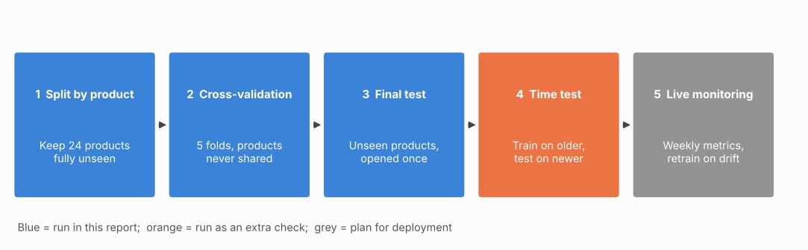
In plain words: Testing a model on the data it learned from is like marking a student’s exam with the answers they memorised. So we test in stages, each harder than the last, and each answers one question.

Figure 1. The five validation stages (blue: run in this report; orange: extra check; grey: planned for live use)

Stage | Question | How | Pass rule and outcome
1. Split by product | Does it work on products it has never seen? | 74 products for training, 24 kept aside; a product never appears on both sides | Test AUC 0.890 is within 0.01 of the cross-validated 0.889: pass
2. Cross-validation | Is the score stable, and can we set a cut-off without peeking? | 5 folds, products kept together; cut-offs set on out-of-fold scores | Recall at the target 70% is 68.3% on test: pass
3. Final test | What will we really get? | Opened once, after all choices; bootstrap over products gives the plausible range | AUC 0.877 to 0.905; PR AUC 0.488  to 0.602: pass
4. Time test | Does it work on tomorrow’s reviews? | Train on reviews before 2021-06-23 (105,397), test on later ones  (35,038) | AUC 0.896 (no drop); recall 71.0%: pass
5. Live monitoring (plan) | Is it still working after launch? | Weekly AUC, recall and precision on a labelled sample; alert if AUC falls by more than 0.05; retrain every quarter | To be set up

Two further safeguards from Week 5 are carried into this plan. First, learning curves guard against overfitting: a single deep tree scored 0.98 on its training data but 0.75 on new data, so tree depth and boosting rounds were limited. Second, features that appear after a review is posted were removed: helpful votes raised the score from 0.890 to 0.916 on test, but they do not exist at the moment a review arrives, so using them would have overstated the tool.

Results
In plain words: This section shows the evidence as charts and tables. Each chart has a one-line reading guide, so a non-technical reader can follow it.

Headline numbers on unseen products

Measure | Result | 95% plausible range (bootstrap over products) | Random guess
ROC AUC | 0.890 | 0.877 to 0.905 | 0.500
PR AUC | 0.548 | 0.488 to 0.602 | 0.100
Recall at the 70% target | 68.3% | 63.3% to 72.1% | 17% (the share flagged)
Precision at the 70% target | 39.8% | 34.8% to 45.5% | 10.0%
Calibration error | 0.0053 | below the 0.02 rule | -

The plausible ranges come from resampling whole products 1,000 times, because reviews of the same product are not independent. They are wider than a plain test of 29,226 reviews would suggest, and are the honest range to quote.

Ranking quality
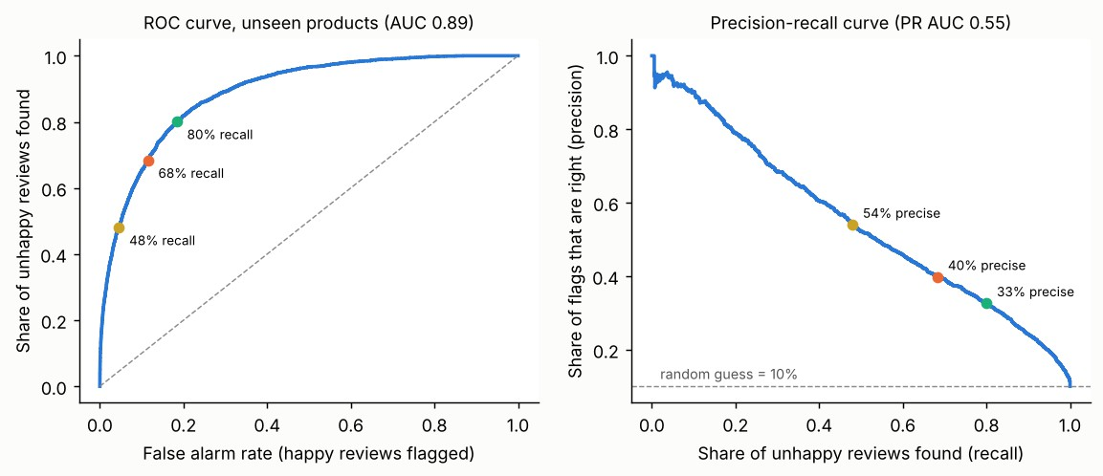
Figure 2. ROC curve (left) and precision-recall curve (right) on unseen products, with the three working settings marked
Reading guide: the further the blue line bends towards the top-left (left chart) or stays high (right chart), the better. The dots show three cut-offs a team could pick.

The three working settings

Setting (target recall) | Cut-off | Reviews flagged | Precision | Recall | F1 | Accuracy
Strict (50%) | 0.32 | 8.9% | 54.0% | 48.0% | 0.51 | 90.7%
Balanced (70%) | 0.19 | 17.2% | 39.8% | 68.3% | 0.50 | 86.5%
Broad (80%) | 0.13 | 24.6% | 32.6% | 80.0% | 0.46 | 81.4%
Best F1 | 0.26 | 11.9% | 47.8% | 56.9% | 0.52 | 89.5%
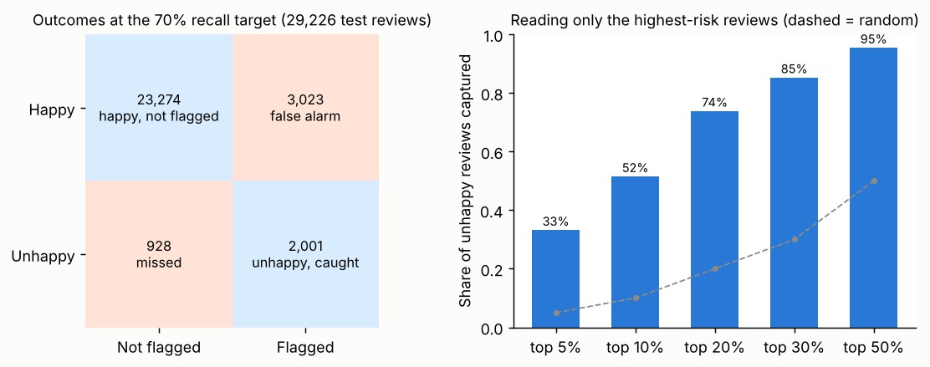
Figure 3. Left: what happens to 29,226 test reviews at the balanced setting. Right: share of all unhappy reviews found by reading only the highest-risk reviews
Reading guide: in the left chart, blue boxes are correct decisions and orange boxes are errors. In the right chart, reading just the top 10% of reviews by risk finds 52% of all unhappy reviews (5.2 times better than random); the top 20% finds 74%.

Honest percentages (calibration)
When the model says a review has a 50% risk, about 52% turn out unhappy; when it says 4%, about 4%. The average gap across ten risk bands is 0.0053 (0.5 percentage points). This means risk scores can be shown to staff as percentages and used in alert rules.

Where the model is weaker
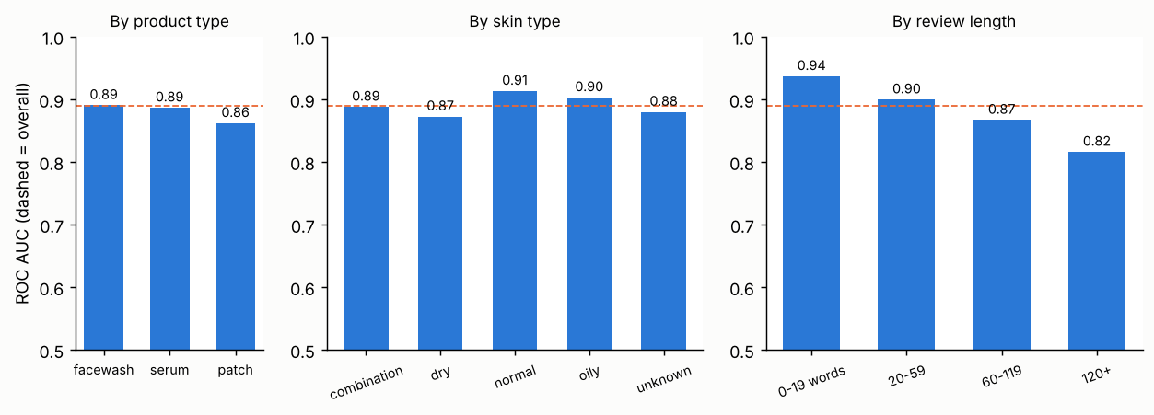
Figure 4. ROC AUC by product type, skin type and review length on unseen products (dashed line: overall AUC)

Group | Reviews | Unhappy share | AUC | Recall (70% setting) | Precision
Product type: facewash | 4,522 | 9% | 0.89 | 63% | 41%
Product type: serum | 24,125 | 9% | 0.89 | 68% | 38%
Product type: patch | 579 | 41% | 0.86 | 83% | 67%
Skin type: combination | 15,482 | 9% | 0.89 | 67% | 39%
Skin type: dry | 5,386 | 12% | 0.87 | 67% | 39%
Skin type: normal | 3,812 | 9% | 0.91 | 75% | 44%
Skin type: oily | 3,149 | 9% | 0.90 | 70% | 38%
Skin type: unknown | 1,397 | 13% | 0.88 | 72% | 43%
Length: 0-19 words | 2,845 | 13% | 0.94 | 78% | 55%
Length: 20-59 | 15,101 | 10% | 0.90 | 69% | 41%
Length: 60-119 | 8,814 | 10% | 0.87 | 66% | 36%
Length: 120+ | 2,466 | 8% | 0.82 | 57% | 30%

    - All groups pass the 0.80 rule (lowest: long reviews, 0.82). Product types and skin types are within 0.05 of each other, so the tool is not biased towards one product type.
    - Long reviews are the main weakness. Reviews of 120 words or more mix praise and complaint ("love the texture but it broke me out"), and the model catches only 57% of the unhappy ones. Short reviews of under 20 words are easiest (recall 78%). Action: send long, mixed reviews to a person.
    - Dry skin is a little weaker (AUC 0.87) and has more unhappy reviews (12% against about 9% to 10% for others). Worth a closer look with labelled data.
    - The one patch product scores AUC 0.86 and the model finds 83% of its unhappy reviews, but it is one product, so this is a case study.

Does it hold up over time?
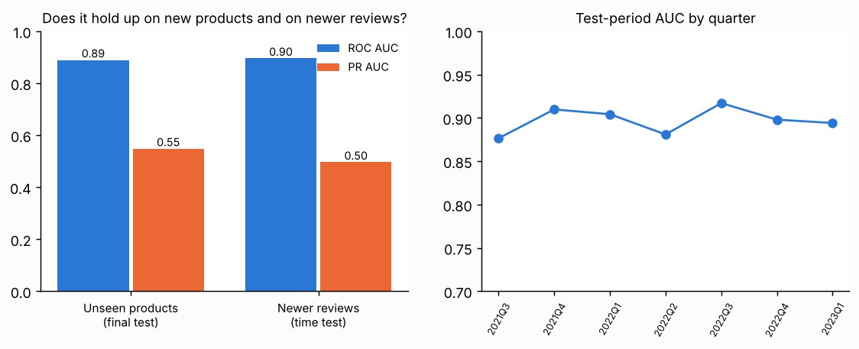
Figure 5. Left: results on unseen products and on newer reviews. Right: AUC by quarter in the later period
Trained only on reviews before 2021-06-23, the model scores AUC 0.896 on the later 35,038 reviews, and stays between 0.88 and 0.92 in every quarter. With the cut-off set on the older data, recall stays at 71%. One change to expect: precision falls to 35%, because the share of unhappy reviews in the later period dropped from 10.3% to 8.4% and precision depends on how common unhappy reviews are. This is why monitoring (stage 5) tracks both numbers.

The other models from Week 5, in one table

Task | Model | Result | Reading
Predict the star rating | Gradient boosting | RMSE 0.89 stars (mean baseline 1.12), R² 0.37 | Good for ranking products, weak for single reviews
Group products by complaint type | k-means, 5 groups | Silhouette 0.23, stable across restarts (ARI 0.83) | Tendencies, not sharp types
Forecast monthly unhappy share | Linear trend | RMSE 0.024 vs naive 0.027 | Small gain; planning aid only
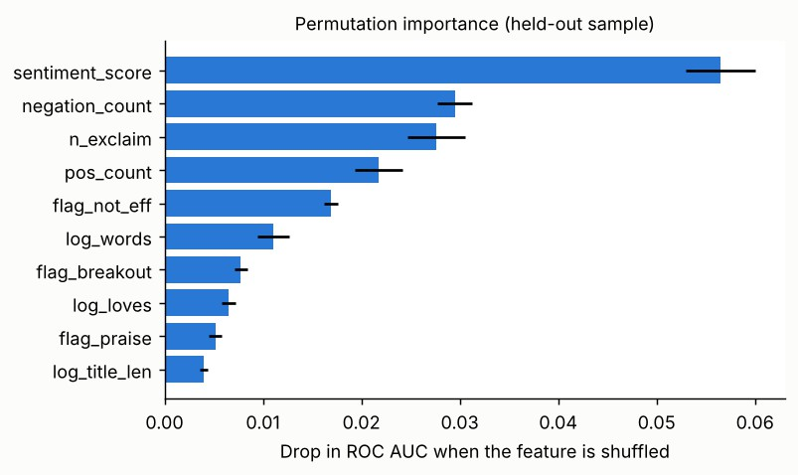
Figure 6. What the model relies on: shuffling these features hurts its accuracy most
Reading guide: the longer the bar, the more the model depends on that feature. Customers’ own words (overall sentiment, negations such as "not" and "never", exclamation marks, "not effective"

phrases) matter most; price and ingredient facts matter little for predicting whether a review is unhappy.

What the Metrics Mean for the Business
In plain words: Each number below is translated into a decision a manager can make. "Per 10,000 reviews" is used so the figures feel like real workloads.

Metric | What it says here | Business meaning
ROC AUC 0.89 | Ranking is strong and stable on new products and newer reviews | The risk score can be trusted to order reviews from most to least worrying
PR AUC 0.55 | About 5 times better than random | A flagged review deserves attention; it is not noise
Recall 68% | About 2 in 3 unhappy reviews found | One in three upset customers is still missed, so the tool supports, and does not replace, regular review reading
Precision 40% | About 4 in 10 flags are right | Six in ten flags are false alarms; keep the check quick (a 10-second glance)
Flagged share 17% | Size of the queue | Sets staffing: about 1,719 reads per 10,000 reviews
Calibration error 0.005 | Percentages are honest | Safe to set alert rules like "notify above 50% risk"
Long-review recall 57% | Weakest group | Route long, mixed reviews to a person
Time-test recall 71% | Holds on newer reviews | Safe to pilot now; retrain quarterly

Impact per 10,000 new reviews

Setting | Unhappy (actual) | Reviews to read | Found | False alarms | Missed
Strict (50% recall) | 1,002 | 890 | 481 | 409 | 521
Balanced (70% recall) | 1,002 | 1,719 | 685 | 1,034 | 318
Broad (80% recall) | 1,002 | 2,457 | 802 | 1,655 | 200

How to choose: a small team can start at the strict setting (about 890 reads per 10,000 reviews, half the unhappy ones found). A brand with a launch to protect can use the broad setting. Money figures are not shown because cost per review and value of a saved customer are brand-specific; the brand should multiply these counts by its own numbers.

Mock-up: weekly review-risk dashboard
Sketch of what a brand manager would see. Figures are illustrative, not real products.

Product (example) | Reviews this week | Predicted unhappy share | Main complaint theme | Suggested action
Cleanser A | 420 | 11% | Irritation | Add patch-test advice; check for new batch issues
Serum B (retinoid) | 260 | 9% | Irritation, peeling | Send "start slowly" guidance to new buyers
Patch C | 55 | 41% | "Did not work" | Review claims and how-to-use card
Cleanser D | 310 | 8% | Scent mentions | Keep; clarify scent in the description
Alert rule examples: a product’s predicted unhappy share rises 5 points above its own 8-week average; or more than 20 reviews in a week score above 50% risk.

Business Impact: Brand, Marketing and Customer Engagement
In plain words: The score is a tool; the findings behind it are what change decisions. Below, each area names the evidence from the real reviews, the decision it supports, and the number to watch.

Market context. India’s beauty and personal care market was reported at Rs. 74,557 crore in 2026, and organic personal care at US$ 1.1 billion in 2025, forecast at US$ 3.0 billion by 2034 (CAGR 10.76%). More than 30 million people shop beauty and personal care through quick-commerce apps each month (IBEF, 2026). Reviews are the main place new buyers learn about a product, and regulation (Cosmetics Rules, 2020; Ecomark, 2024) now expects "natural" and "organic" claims to be justified (IBEF, 2026). A tool that reads reviews at scale suits this market.

Brand decisions

Decision | Evidence (real reviews) | Action and KPI
Patch positioning | The patch averages 3.04 stars vs 4.31 for serums; 43% of its low ratings say "did not work"; only 50% recommend it; just 7% mention deep lesions | Promise only what it does (dark-spot or surface use), show time-to-result. KPI: share of low reviews saying "did not work"
Cleanser formulation | Irritation or smell is 43% of low-rated facewash reviews; sensitive-skin mentions report irritation 34% of the time vs 13% | Add a gentle variant and patch-test advice. KPI: irritation-word share among sensitive-skin reviewers
Active-ingredient products | Retinoid products: irritation words in 22% of reviews vs 16% for others, with few 1 to 2 star ratings (6%) | Customers tolerate a controlled "tingle" if told to expect it; set expectations, do not remove the active
Which products to keep | The model ranks products well (ρ = 0.78 on unseen products) | Use predicted unhappy share with recommend rate as a second quality check

Marketing strategy

Area | Evidence | Action and KPI
"Fragrance-free" claims | Fragranced products showed no extra irritation (adjusted odds ratio 0.87, range 0.70 to 1.10); fragrance-free products more often carry strong actives | Do not sell "fragrance-free" as "gentle". Add "tested on sensitive skin" only if it is true. KPI: complaints that contradict the claim
Scent as a feature | Cleanser group with 46% scent mentions has an average unhappy share (9%) | Talk about scent openly; do not remove it blindly; test in a small trial
Expectation setting | Efficacy-doubted cluster has the lowest mean rating (3.83) | Put "how long it takes" and "how many to use" on pack and product page
Claim monitoring | Regulators expect claims to be justified (IBEF, 2026) | Weekly check for reviews that contradict "gentle", "natural" or "clinically tested". KPI: number of contradictions found and fixed

Customer engagement

Area | Evidence | Action and KPI
Faster recovery of upset customers | The tool finds about 68% of unhappy reviews and ranks them: the top 10% by risk holds 52% of them | Reply to the top-risk reviews within 24 hours. KPI: time to first reply; share of replied reviews later updated
Smarter replies | Complaint themes differ by product type (Week 4) | Use theme-based reply templates: irritation (advice and a refund option), "did not work" (usage guide)

Area | Evidence | Action and KPI
Sensitive-skin community | Sensitive-skin mentions are 2.6 times more likely to describe irritation | Invite them to a sampling or advice programme. KPI: repeat purchase among replied customers
Listening in Hindi and Hinglish | The model is trained on English reviews from one retailer | Collect and label Indian-market reviews before use; track recall by language

Recommendations
In plain words: Eight actions, in priority order. Each one has an owner, a timeline and a number to track, so progress can be checked.

# | Recommendation | Owner | When | KPI (target to set by the team)
1 | Pilot review triage at the balanced (70%) setting for four weeks on one product range | Customer care + analytics | 0 to 30 days | Share of flagged reviews answered within 24 h; hit rate of flags (about 40%)
2 | Rewrite the spot-patch claim and how-to-use card; add time-to-result | Brand + packaging | 0 to 60 days | Fall in "did not work" share of low reviews; recommend rate (now 50%)
3 | Drop "fragrance-free" as the main safety message; label strong actives and give a starter routine | Marketing + regulatory | 0 to 60 days | Irritation-word share in reviews of retinoid products (now 22%)
4 | Add recommend rate and predicted unhappy share next to stars in product reviews | Category + analytics | 30 to 60 days | Agreement between the two measures; fewer surprises after launch
5 | Weekly claim-contradiction check on reviews | Compliance | 30 to 90 days | Contradictions found and corrected
6 | Hand-label 600 to 1,000 reviews by reason (failure, side effect, misapplication) and add Indian-market and Hinglish reviews | Analytics | 30 to 90 days | Labelled sample size; model recall on Hindi/Hinglish reviews
7 | Set up monitoring: weekly AUC, recall and precision; retrain every quarter | Analytics | 60 to 90 days | Alert if AUC falls by more than 0.05
8 | Send long, mixed reviews (120+ words) to human readers | Customer care | With the pilot | Recall on long reviews (now 57%)

What not to do
- Do not use the score to judge or score individual customers; it ranks reviews for reading, not people.
- Do not cut fragrance from the whole range on the strength of these results: the data shows no extra irritation, not that scent is harmless for everyone.
- Do not generalise the patch findings: they come from one product on one retailer.
- Do not launch without monitoring: the share of unhappy reviews changes over time, and precision moves with it.

Risks and Limitations

Risk | What it means here | How it is handled
Stars are a proxy for "unhappy" | A 1 to 2 star review is used as the target; it does not say why | Label reasons by hand (Recommendation 6)

Risk | What it means here | How it is handled
One retailer, English text | Sephora reviews in English; Indian shoppers and Hinglish text may behave differently | Test and retrain on Indian-market data before use there
One patch product | Patch findings describe a single micro-tip dark-spot patch | Add more patch products and reviews
Text features carry the signal | The score reads the same words as the star rating; it adds value in speed and ranking, not in discovering new causes | Combine with theme analysis and human reading
Changing base rate | Unhappy share fell from 10.3% to 8.4% in the later period; precision fell with it | Monitor precision and recall weekly; reset the cut-off if needed
Associations, not causes | A link between irritation words and retinoids does not prove the retinoid is the only cause | Treat as leads for trials, not proof
Small number of unseen products | Only 24 products in the final test; the bootstrap range reflects this | More products will narrow the ranges

Final Summary
The project began with one question: why do customers of skincare products become unhappy, and can a brand see it early? The answer has three parts.
What we found about customers. Unhappiness has different causes in different products. The spot patch is rated far lower than serums and cleansers (3.04 against about 4.3) mainly because customers feel it did not work, while cleansers lose customers through skin reaction. Fragrance in the ingredient list did not raise irritation reports; strong actives such as retinoids did. Sensitive-skin reviewers report irritation 2.6 times as often as others.
What we built and how well it works. A risk score that reads a review and says how likely it is to be unhappy. On products it had never seen, it ranks reviews well (AUC 0.89), finds about two in three unhappy reviews at a workload of about one in six reviews, and gives honest percentages. It holds on newer reviews. It is weaker on long, mixed reviews and has only been tested on one retailer’s English reviews.
What to do. Start with a four-week triage pilot; fix the patch’s promise and instructions; stop using "fragrance-free" as a stand-in for "gentle" and explain strong actives instead; judge products by recommend rate and risk score as well as stars; and invest in labelled Indian-market reviews before relying on the tool there. Monitor weekly and retrain every quarter.
Taken together, the work moves a brand from "this product is rated 3.0, fix it" to "this product is rated 3.0 because customers expected visible results and did not get them, so fix the claim and the instructions first, and watch the risk score to see whether it worked."

Glossary

Term | Plain meaning
Unhappy review | A review that gives 1 or 2 stars
Recall | Of all the unhappy reviews, the share the tool finds
Precision | Of the reviews the tool flags, the share that are truly unhappy
ROC AUC | A 0 to 1 score for how well the tool ranks unhappy reviews above happy ones; 0.5 is a coin toss, 1 is perfect

Term | Plain meaning
PR AUC | Like AUC but focused on the rare unhappy reviews; the random value equals the unhappy share (10%)
Cut-off (threshold) | The risk score above which a review is flagged
Calibration | Whether a stated 30% risk means about 30% in practice
Unseen products | Products kept completely out of training, used to test fairly
Bootstrap range | The plausible range of a result found by repeating the test on resampled products
Leakage | When a model uses information it would not have in real life (for example votes that arrive after a review)
Overfitting | Memorising the training data so well that new data is handled badly

References

Evaluation and validation
- Fawcett, T. (2006). An introduction to ROC analysis. Pattern Recognition Letters, 27(8), 861–874.
- Davis, J., & Goadrich, M. (2006). The relationship between precision-recall and ROC curves. Proceedings of ICML, 233–240.
- Saito, T., & Rehmsmeier, M. (2015). The precision-recall plot is more informative than the ROC plot when evaluating binary classifiers on imbalanced datasets. PLoS ONE, 10(3), e0118432.
- Niculescu-Mizil, A., & Caruana, R. (2005). Predicting good probabilities with supervised learning. Proceedings of ICML, 625–632.
- Cawley, G. C., & Talbot, N. L. C. (2010). On over-fitting in model selection and subsequent selection bias in performance evaluation. Journal of Machine Learning Research, 11, 2079–2107.
- Efron, B., & Tibshirani, R. J. (1993). An Introduction to the Bootstrap. Chapman & Hall.
- Kaufman, S., Rosset, S., Perlich, C., & Stitelman, O. (2012). Leakage in data mining: formulation, detection, and avoidance. ACM Transactions on Knowledge Discovery from Data, 6(4), 1–21.
- Kapoor, S., & Narayanan, A. (2023). Leakage and the reproducibility crisis in machine-learning-based science. Patterns, 4(9), 100804.
- Hyndman, R. J., & Athanasopoulos, G. (2021). Forecasting: Principles and Practice (3rd ed.). OTexts.

Models and software
- Friedman, J. H. (2001). Greedy function approximation: a gradient boosting machine. Annals of Statistics, 29(5), 1189–1232.
- Pedregosa, F., et al. (2011). Scikit-learn: machine learning in Python. Journal of Machine Learning Research, 12, 2825–2830.

Communicating results

- Knaflic, C. N. (2015). Storytelling with Data: A Data Visualization Guide for Business Professionals. Wiley.
- Few, S. (2013). Information Dashboard Design (2nd ed.). Analytics Press.

Industry context and data
- IBEF (2026, 30 October). The rise of organic personal care products among Indian consumers. India Brand Equity Foundation (market figures cited from IMARC Group).
- Economic Times (date not verified). India is now the fastest-growing online market globally for beauty products: NielsenIQ (cited by headline only; the page could not be opened here).
- Sephora Products and Skincare Reviews (Kaggle dataset by nadyinky), review files and product_info.csv, accessed 1 November 2026.

Appendix: Files and Environment

File | Purpose
w6_evaluation.py | Week 6 evaluation: final test, bootstrap ranges, subgroups, time test, charts
w5_models.py, real_eda.py | Earlier steps: models (Week 5) and features (Week 4)
w6_results.json | Every Week 6 number in this report
w5_results.json, real_results.json | Week 5 and Week 4 numbers quoted here
To reproduce: place real_features.csv next to w6_evaluation.py and run python w6_evaluation.py (pandas, NumPy, SciPy, scikit-learn, matplotlib; about two minutes). Environment: Python 3.13, pandas 3.0.5, NumPy 2.5.3, scikit-learn 1.9.1, SciPy 1.18.1. Random seed 42. This document analyses public customer reviews and is not medical advice.

